Non-Technical Summary (NTS) Report

Prepared for: European Bank of Reconstruction and Development

July 2020

List of Acronyms
Acronym | Explanation
AAWT | Annual Average Weekday Traffic
AoA | Area of Analysis
AQ | Air Quality
AQMP | Air Quality Management Plan
BAP | Biodiversity Action Plan
CESMP | Construction Environmental and Social Management Plan
CETI | Centre for Ecotoxicological Research
CHA | Critical Habitat Assessment
CHS | Community Health and Safety
CNVMP | Construction Noise and Vibration Management Plan
CR | Critically Endangered
CTMP | Construction Traffic Management Plan
dB | Decibel
E&S | Environmental and Social
EBRD | European Bank of Reconstruction and Development
EC | European Commission
EIA | Environmental Impact Assessment
EN | Endangered
ESIA | Environmental and Social Impact Assessment
GIP | Good International Practice
PAA | Project Affected Area
PAH | Polyaromatic Hydrocarbons

- Introduction
This document is the Non-Technical Summary (NTS) of the Environmental and Social Impact Assessment (ESIA) of the proposed Rehabilitation and expansion of the Tivat to Jaz section of the M-2 road in Montenegro (the Project). The Project is being considered for financing by the European Bank for Reconstruction and Development (EBRD) and so it is necessary to demonstrate that construction and operation of the Project will be in accordance with the EBRD’s Environmental and Social Policy (2014). A requirement of this Policy is that an ESIA be undertaken, and that the resulting ESIA Report and associated documents be disclosed for public consultation for a minimum 120 days.
The ESIA Report identifies and characterises potential Environmental and Social (E&S) risks and impacts that could result from both the construction and operation of the Project and presents a suite of appropriate mitigation measures to avoid or minimise these impacts. The ESIA builds on the national Environmental Impact Assessment (EIA) that was undertaken by the multidisciplinary team of experts in October 2019, as part of the Montenegrin regulatory construction permitting process.
This NTS is a stand‐alone document that is intended to provide all interested parties and stakeholders with an overview of the outcome of the ESIA process in non‐technical language. It should be noted that certain recommendations may be subject to change due to restrictions imposed by the Covid-19 pandemic.
- Project Description
The Project will involve the rehabilitation and expansion of the Tivat to Jaz Main road (the M-2) from approximately 100m before the entrance to Tivat Airport to the end of the existing intersection at Jaz, north of Budva, approximately 16km in length. The Project incorporates the territories of three municipalities in the Coastal region of Montenegro, namely Budva, Kotor and Tivat, and their associated settlements located along the M-2 route. The project will contribute to the strategic development plans of the local municipalities. The works will include widening the existing two-lane road to create a four-lane road (two-lanes in each direction) with a 2m wide central reservation, 2m wide sidewalks and a vegetated verge. In addition, seven road bridges, four culverts and one footbridge will be either constructed or reconstructed and 11 new roundabout junctions will be created. Two existing roundabout junctions will also be reconstructed. The upgraded road corridor will be around 20m wide. In the section between Tivat airport and Radanovici a section of the road will deviate from the existing road, though this new road section passes through government-owned land (see ESIA for details). The proposed project route is shown in Figure 1 overleaf.
Construction is expected to begin in 2021 and last approximately 24 months, however the programme might be amended due to the Covid-19 pandemic. No construction work is planned to take place during the summer months (June, July, August) to avoid worsening congestion and disruption in the area. Construction works will be carried out between 09.00 – 17.00 (unless by exception) and access to local businesses will be maintained throughout the entire construction period. Construction will take place in 3 phases as shown below:
Table 1: Construction Phasing Schedule
Phase 1 | Construction of the new sections of the road, including bridges. Traffic will continue to use the existing road.
Phase 2 | Traffic will be moved onto the sections of the road that have been completed during Phase 1. Due to the limited size of the carriageway and to minimise disruption, traffic flows will alternate and be signal controlled during this phase. Demolition of the existing road and construction of the remaining sections of the road will take place in parallel.
Phase 3 | Installation of kerbs, barriers and pedestrian fencing. Installation of the final road surface.
Figure 1: Project route

In accordance with EBRD’s Environmental and Social Policy (2014) the project has been Categorised as a “Category A” project by the Bank, which reflects the intention to widen the road from 2 to 4 lanes over a greater than 10 km continuous length and the requirement for land acquisition, with associated potential for economic and physical displacement.

- Need for the Project
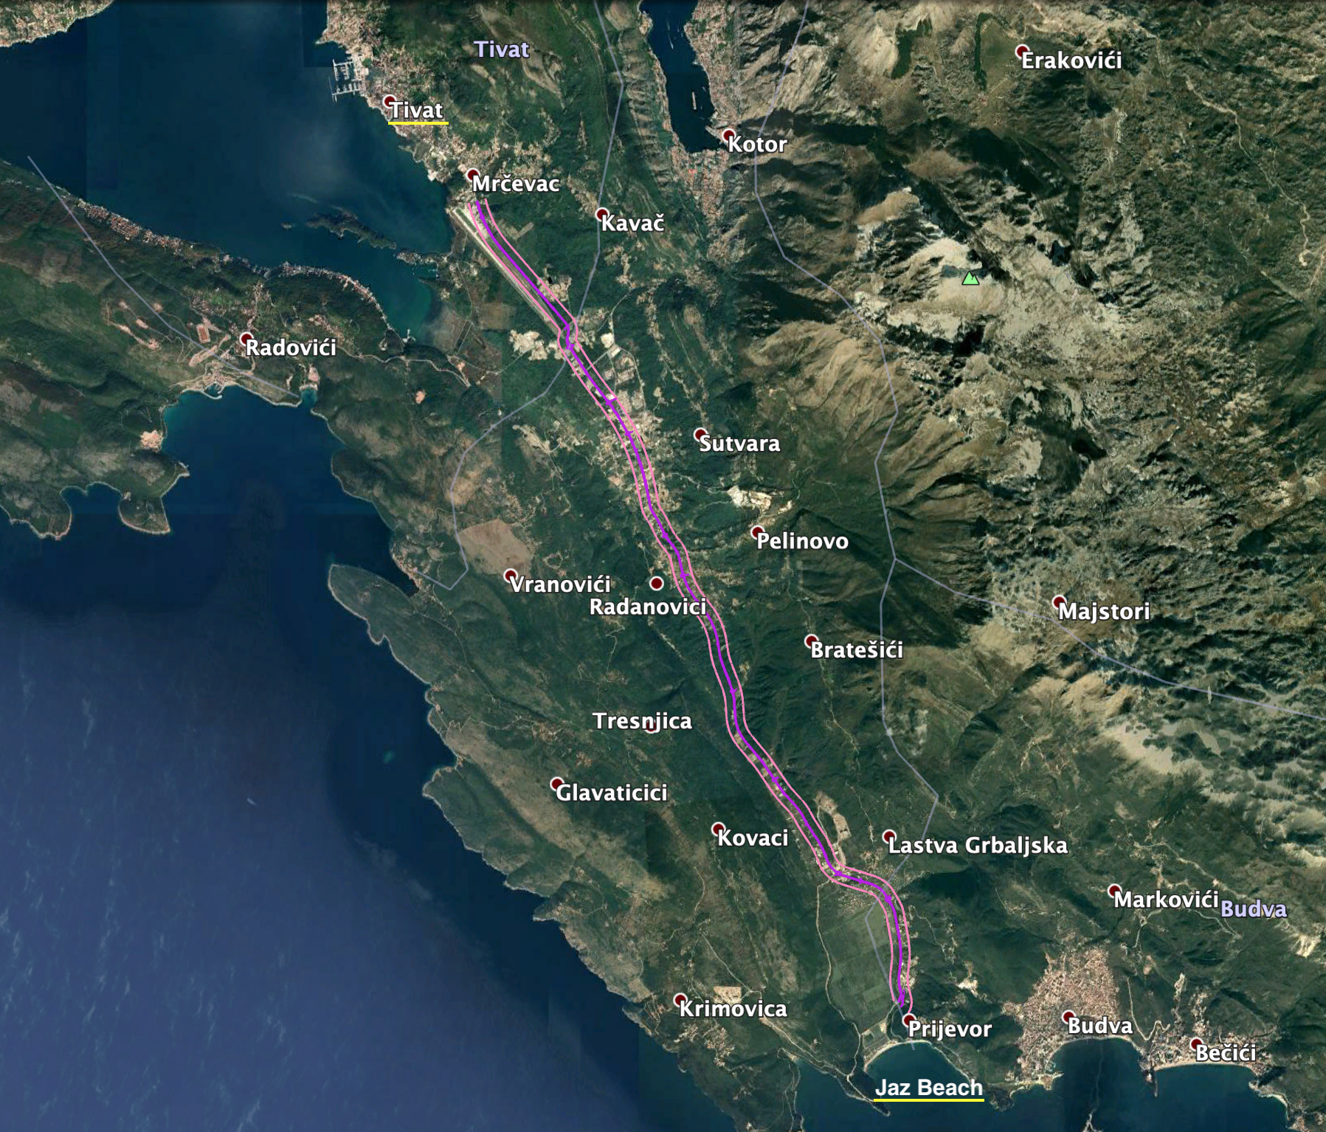
The current capacity of the road is insufficient for existing traffic volumes during the summer tourist season when vehicle numbers are more than double those of the winter and significant queues often develop. This congestion is expected to worsen as Montenegro is predicted to experience considerable growth in vehicle numbers. The situation is made worse as a result of multiple minor accesses onto the road, a lack of left turn lanes and uncontrolled parking along the edge of the road. A Road Safety Audit undertaken in 2018 also identified a number of safety concerns including inappropriate/inadequate guardrails and restraints, the proliferation of uncontrolled advertising resulting in driver distraction, and the absence of signage, lighting and marking at bus stops. The existing road is also subject to regular and extensive flooding in the winter months rendering the road impassable at times, and this is expected to worsen with the effects of climate change.
There have been no major upgrades or improvements to this section of the M-2 road in recent years and only minor repairs have been undertaken to short stretches during regular maintenance. The entire section of road now requires rehabilitation / reconstruction as well as upgrading to cope with predicted future traffic volumes.
- ESIA Purpose & Process
The ESIA process involves the following phases:

- Pre-assessment activities such as screening for key environmental, social and health and safety issues that will need to be considered and scoping to identify potential impacts resulting from the Project that are likely to be significant and will therefore need further assessment;
- The ESIA itself, which involves the detailed assessment of the likely significant impacts and the development of control measures that could be implemented to mitigate (i.e. reduce or eliminate) adverse impacts; and
- The post-assessment stage, which requires the development of procedures for the review and monitoring of Project environmental, social and H&S performance, to help ensure that the proposed mitigation measures are being implemented and are effective during construction and operation of the Project.

Following the scoping phase undertaken in December 2019, the topics identified for further investigation in the ESIA were air quality, biodiversity, noise and vibration, social impacts, traffic and transport and water resources. The findings of the ESIA process under each of these topic headings are given below for both construction and operation of the Project. The ESIA also considers cumulative effects (i.e. those resulting from other projects or developments in the area) and includes consideration of relevant legislation, policy and guidance.
- Impacts on Traffic & Transport
The M-2 road is one of the busiest and most strategic routes in Montenegro, serving the coastal regions and providing an important tourist link for the country. The road has a high seasonal variation in traffic flows (with peak traffic months being June, July and August) and a high risk of traffic accidents. Passenger cars are the most frequent type of vehicles on the road, with relatively few heavy trucks. The speed limit varies from 50 kph – 80 kph as the route passes between urban and more rural areas. Traffic has been predicted to grow at a rate of around 4% per annum, and the Project has been designed to support this growth for at least the next 15 years.
A number of additional initiatives, either existing or in-development, are also likely to impact traffic flows along the M-2. Analysis of the information available for these initiatives on how they will alter traffic flows, and if-and-when they may come to fruition, is inconclusive. For example, the proposed Adriatic to Ionian Motorway (identified in the Transport Development Strategy 2019-2035) may help to reduce traffic growth on the project road by diverting some ‘through’ traffic. Conversely however, the proposed European motorway project may result in increased traffic as the Montenegro tourist sites become more accessible to wider part of Europe. The Government of Montenegro aims to enhance tourism through improvements in road and rail (Treaty establishing Transport Community 2017 between Albania, BiH, North Macedonia, Kosovo, Montenegro). Additionally, that treaty agreement wishes to improve efficiency at borders, which will also potentially result in increased vehicular based transport. Local airport expansion projects and regional economic development will also have a role to play.
  - Construction Impacts and Mitigation
Construction activities are expected to affect users of the local road network through the introduction of construction vehicles and heavy plant on the roads, an increase in traffic due to the transport of materials, goods and workers to and from construction sites, and partial road closures to enable works to take place. These activities will change existing traffic flows and exacerbate existing congestion pinch points, with an associated increased risk of traffic accidents. Such impacts will be of short-term duration and are considered to be moderate adverse.
The primary mitigation measures to minimise impacts to through traffic during construction will be the scheduling of works outside of the peak summer months and the use of a robust Construction Traffic Management Plan (CTMP) designed to address potential impacts associated with delay, connectivity and safety. The CTMP should maintain safe vehicle and pedestrian access through areas where construction work is ongoing, whilst also ensuring a safe working environment for roadside workers. Access to local businesses, homes, schools, and bus stops will also be maintained and transport to and from site offices and work compounds will be managed including to avoid debris and mud being introduced onto the road network.
The CTMP will minimise as far as practical the impacts of the Project on the highway network and surrounding environment. However, it is inevitable that some impacts will remain and so ongoing dialogue with communities and other stakeholders, in accordance with the Project Stakeholder Engagement Plan (SEP) will be crucial to minimise residual impacts.
  - Operational Impacts and Mitigation
The expected traffic growth rate will see vehicle numbers doubling by 2034, which will erode the operational benefits from the Project over time. However, in the shorter term, the Project is expected to result in reduced journey times for most travellers, particularly during the peak summer months (as there will be less congestion), which is considered a significant beneficial impact. The divided road will also improve road safety by reducing the likelihood of head-on type accidents, although it may also encourage higher average vehicle speeds; overall safety improvements are therefore considered to be a moderate beneficial impact. The introduction of the central reservation may, however, reduce local connectivity and access including by the prevention of left in and out movements from premises along the roadside, which is considered a moderate adverse impact. Pedestrians seeking to cross the road will also need to cross four lanes of traffic (although the central reservation will provide a refuge area) and the introduction of additional bridges / underpasses or push button, signalised pedestrian crossings may be required to avoid adverse impacts on pedestrians.
- Impacts from Noise & Vibration
The noise environment in the vicinity of the Project is already heavily influenced by human activities; key sources of noise include both traffic using the M2 road (and local branch roads) and Tivat Airport. Noise monitoring at four locations has demonstrated a noisier daytime environment as a result of the M2 road compared to the night time when traffic flows are reduced; daytime noise levels ranged from 58.5 – 64.3 dB with nightime 49.0 – 54.6 dB. Currently noise in the area already exceeds the daytime levels for the relevant acoustic zones (e.g. 60dB for Zones heavily influenced by noise emanating from road traffic - Official Gazette of Montenegro No. 060/11).
  - Construction Impacts and Mitigation
Noise impacts during construction are expected to be relatively short-term and transient in nature as the construction activities progress along the Project route.
Local guidance (Rulebook 060/11 of 16/12/2019 - under Article 3) states that where permitted by the competent authority, open air construction activity may exceed the permitted level for the defined area by 5dB(A).
Along the Project road, the areas found would be typified by “residential” and “zones heavily influenced by noise emanating from road traffic” which translates into limits of 60dB to 65dB depending upon zone clarification.
Daytime construction noise levels immediately along the Project route are expected to be between 60 – 65dB(A). Noise levels decrease rapidly with distance, and so it is only necessary to consider sensitive receptors within 100m of the works, which includes a number of properties in Southern Tivat, Radanovici and Poljice as well as hotels/guest houses in Jaz/Budva. Construction noise and vibration impacts will be mitigated through the use of a specific Construction Noise and Vibration Management Plan (CNVMP), which will prescribe key control measures to be employed by the contractor. As well as controls on construction hours, these will include controls aligned with Good International Practice (GIP) to minimise construction noise and vibration impacts at source. The CNVMP will apply to the whole Project route and will enable impacts from construction activities to be controlled to acceptable levels so that there will be no significant impact.
  - Operational Impacts and Mitigation
The predicted increase in traffic flows means that noise will increase both with and without the Project. Summer noise levels without the Project are predicted to increase by 1.7dB in the long term, solely due to the increase in traffic flows. With the project, noise levels are predicted to increase by 0.9 – 2.9dB dependent on the location under consideration. The Project reduces congestion, particularly in the summer, which enables traffic to travel at greater speeds, resulting in a minor, insignificant increase in noise.
Currently noise in the area already exceeds the daytime levels for the relevant acoustic zones and it will continue to do so, with and without the Project.
There is no significant impact on noise levels as a result of the Project.
- Impacts on Air Quality
Montenegrin air quality monitoring locations are defined at a national level and air quality measurements are undertaken by the Montenegrin Centre for Ecotoxicological Research (CETI). The most recent results from the closest monitoring stations to the Project indicate that air quality parameters are below the relevant (EU) air quality limits / values for the majority of pollutants monitored. However, levels of polyaromatic hydrocarbons (PAH – expressed as benzo(a)pyrene) were slightly above the relevant target value. Tivat airport is located adjacent to the Project, however, studies at other major international airports have found that the airport contributes little to air pollution and that the impact of road traffic is far greater. The lack of significant industrial land-uses in the area affected by the Project, and the relatively small contribution of the airport to air quality, means that road traffic can be considered the principal source of atmospheric pollution in the Project Affected Area (PAA). Given the lack of air quality monitoring data for the PAA, baseline measurements were taken in January 2020 at three locations. The results from these surveys showed existing levels of air pollutants below the relevant limit values; background levels of PM₁₀ for example were 12.9 μg /m³ compared with an annual limit of 40 μg /m³ and levels close to the road at Nikola Djurkovic School were 16.55 μg /m³.
  - Construction Impacts and Mitigation
Air quality impacts from construction will be managed through Good International Practice (GIP) mitigation measures, including but not limited to, positioning construction activities where possible away from sensitive receptors, erecting screens and barriers around dusty activities and dust suppression using water. Despite this, dust emissions can still arise from demolition, earthworks and construction activities and vehicle movements, and residential buildings and other sensitive receptors located within 50 m of works may be sensitive to dust soiling. Around 100 such residences could be affected, although no sensitive ecological receptors are present within this distance. A construction phase Air Quality Management Plan (AQMP) will be developed by the Principal Contractor to manage such emissions, as well as a monitoring programme to further establish baseline air quality.
With the implementation of the AQMP, there will be no significant residual construction phase effects.
  - Operational Impacts and Mitigation
Given the assumed 4% annual growth in traffic flows, predicted concentrations of operational air pollutants will increase over time, although the assumed increased speeds as a result of the Project will also result in a small reduction in predicted concentrations within 50 m of the road. Whilst the greatest effect of the Project is seen for levels of the pollutant PM₁₀, particularly during the summer months when traffic volumes are higher and the magnitude of the assumed change in speed is also higher (i.e. an increase from 25 – 60 km / h compared with 60 – 70 km / h in winter) the magnitude of impact is considered negligible, especially given the relatively low recorded background concentrations e.g. in 2021, levels of PM₁₀ with the Project are predicted to be 14.1 μg /m³ compared with 13.7 μg /m³). An estimate of the total amounts of pollutants produced each year has also been made based on an annual average speed of 60 km/h along the entire route. The assumed increase in average speed as a result of the Project means that total annual emissions are predicted to be lower than in the absence of the Project. Given the above findings, no mitigation is required for the operational phase of the Project based on the results of the modelling undertaken and there are no significant residual operational phase effects on air quality.
- Impacts on Water Resources
The existing road crosses seven named watercourses – Drenovštica, Gradiošnica, Koložun, Kovački potok, Lukavac, Močali and Vodolježnica as shown in Figure 2 below. Additionally, there are a number of unnamed drainage channels running parallel to the road. The Gradiošnica splits into two branches, one of which joins the Vodolježnica. The Koložun and Vodolježnica rivers ultimately flow into an internationally designated nature conservation site - the Tivat Saline Ramsar site, although the points where the road crosses the Koložun and Vodolježnica are some 4km and 1.2 km respectively upstream of the Ramsar site. The rivers are strongly seasonal and all dry out to a large extent, if not completely, during the summer months. A number of water quality samples were taken in January 2020 and analysed to characterise the existing condition of the watercourses which ultimately flow into Tivat Saline; all samples met the standards set in the Regulation on the Classification and Categorisation of Surface and Groundwater, with the exception of a sample from the River Vodolijeznica upstream of the road. Field notes from this sample recorded the presence of flytipped waste, and a ‘wild’ settlement nearby as well as the presence of the Lovanja landfill upstream.
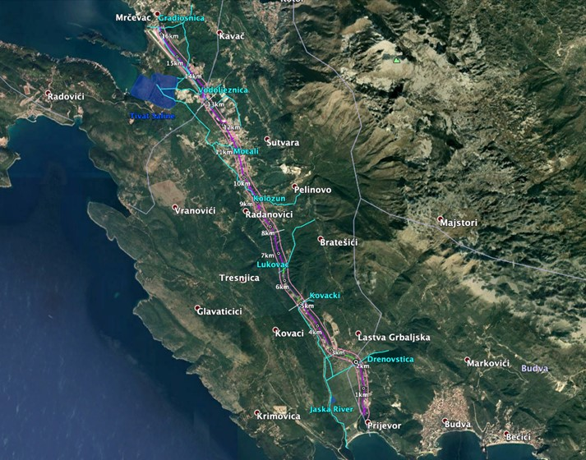
Figure 2: Named rivers in the Project Affected Area and the Tivat Saline Ramsar site
The existing road, although raised on an embankment in places, suffers from flooding, which is assumed to be due to the existing drainage network along the entire route being too small and, in general, poorly maintained.
  - Construction Impacts and Mitigation
The proposed Project will require new bridges and culverts to be built across all watercourses, as well as works to the existing crossings. Construction works therefore have the potential to affect water quality due to direct activities in the watercourses themselves as well as indirect impacts from spillages and runoff. Any effects as a result of works required to create the new bridges and culverts will be temporary and minor – moderate adverse. Construction water demand will be provided by existing utilities and so there will be no abstraction and no impact.
Construction impacts on water quality could range from minor – moderate adverse depending on the duration of the construction activities and the amount of water in the river. Scheduling works either side of the peak summer tourist season, when river levels will be lower (although not completely dry) will help to reduce impacts. If any foundations / structures are constructed from poured concrete, there could be a major impact as liquid cement is highly toxic in aquatic environments. Impacts may also arise from spillages of chemicals, fuels, materials as a result of incorrectly stored materials or from accidents on site. In the absence of mitigation, there could be significant impacts on the Drenovštica, Koložun, Kovački potoc and Lukavac rivers and the Tivat Saline Ramsar site.
A Construction phase Water Resources and Water Quality Management Plan will be developed by the Principal Contractor in consultation with the competent authority and EBRD and in accordance with GIP. General GIP construction mitigation measures will cover the handling and management of hazardous materials (fuel, lubricants, oils etc.) on site, construction vehicle and machinery maintenance management, watercourse management during construction / refurbishment of bridges and culverts. Implementation of the Water Resources and Water Quality Management Plan means that there will be no significant residual effects.
  - Operational Impacts and Mitigation
Operation of the road could result in impacts relating to runoff and drainage. Routine run-off from roads contains a variety of pollutants and so runoff will be directed into the Project’s drainage system, which will be designed to ensure that water will not be discharged without previous adequate treatment. The principal mechanism by which potential operational phase impacts will be mitigated is through the design of the drainage system itself. However, it is essential that the system is appropriately inspected and maintained to ensure its continued function. An Operational phase Water Resources and Water Quality Management Plan will therefore be developed that includes maintenance requirements to avoid blockages, overflow and the direct discharge of untreated runoff into receiving rivers, and requirements for water quality monitoring. With the implementation of the Operational phase Water Resources and Water Quality Management Plan there will be no deterioration in water quality from current levels as a result of the Project and so there will be no significant residual effects on water quality.
The increased impermeable surface area from the widened road will result in larger runoff volumes and the introduction of any new structures within the river channels could change the path of floodwaters, ultimately creating or worsening flood risk. It is understood that flood risk has been considered in the design of the road with the finished road level being at least as high as existing. However, the actual levels are unknown as is the impact of any increase on flood risk of the surrounding area and the extent to which climate change has been considered in the design. Because of these uncertainties a moderate adverse impact has been assumed.
On all operational roads, there is the risk that spillages will occur following a traffic accident. As well as minor spillages of oils and fuels from cars, there is also the potential for major spillages from heavy goods vehicles carrying bulk chemicals or fuel, which may result in an acute pollution incident. The drainage system will be designed to intercept routine spills, however there is the potential that, particularly following a major incident close to bridges, spillages of chemicals or fuels could flow directly into surface waters. The severity of any pollution incident will depend on the volume and nature of the chemicals spilled as well as the time of year, given the seasonal variability in river flows; the potential impact could therefore be major adverse for a large-scale incident. An Emergency Preparedness and Response Plan will be developed in collaboration with the local emergency services and the maintenance contractor, to ensure that any spillages that do occur are effectively controlled and impacts on watercourses are limited as far as possible.
- Impacts on Biodiversity
    - Existing Conditions

Around 45% of the habitats present within the PAA have been subject to a high degree of human modification. The remainder is mainly maquis (Mediterranean shrubland), with areas of deciduous thicket, coastal forest and riparian vegetation along watercourses. Only one protected area is located in close proximity to the Project; Tivat Saline, which is 300m from the road at its closest point. Tivat Saline is nationally designated as a Special Nature Reserve and is also a Ramsar site. Tivat Saline is a salt marsh, a habitat type which has largely disappeared, not just from Montenegro, but from the eastern coast of the Adriatic. It is a globally important area for migratory waterbirds, hosting large congregations of these species. The watercourses in the PAA (shown in Figure 2) and their aquatic vegetation, support a range of species including amphibians such as the European tree frog and Marsh frog, aquatic reptiles including the European pond turtle, and fish including the critically endangered European eel. In the maquis and forest areas, larger mammals are present including the Wild Boar, European wild cat, and Golden Jackal. A number of bat species have also been recorded in the area. Terrestrial reptiles have been recorded across the project area, including Hermann’s tortoise and multiple lizard species. Many of the species present are protected under EU law, including all bat species, the European Wildcat and Hermann’s tortoise.
    - Construction Phase Impacts and Mitigation
Preparation of the working corridor and associated supporting infrastructure will result in the clearance of vegetation, which represents habitat loss for terrestrial species. Drainage channels running alongside the road may have to be removed for road widening, and this represents habitat loss for aquatic reptile and amphibian species. Construction also has the potential to produce air pollution, including dust, which can negatively affect terrestrial vegetation. Construction in and around watercourses can cause pollution and sedimentation, which can have downstream effects. Without sufficient mitigation, downstream effects in the Gradiošnica, Koložun and Vodolježnica watercourses could negatively affect the Tivat Saline protected area.
A number of these impacts will be mitigated through use of GIP e.g. the Construction Air Quality and Water Resources Management Plans described above, others will be mitigated by hiring an on-site ecological expert, who will conduct pre-clearance surveys for nesting birds, bat roosts and protected species in the working corridor, which will be safely relocated if found. Works in and around the watercourses will only occur when the water levels are low and some of the watercourses have dried up completely. The removal of any drainage channels will occur outside of the frog reproductive season to avoid disturbing breeding or destroying spawn/larvae. Habitat temporarily cleared during construction will be restored, and there will be specific Biodiversity awareness training for contractors.
    - Operation Phase Impacts and Mitigation
The operation phase will also have a number of impacts; although these impacts are already present for the original road, an increase in traffic density and road width will increase their severity. There Risk of roadkill will increase given the increased vehicle numbers and speed; this is a particular risk for slow moving species, like Hermann’s tortoise, and large mammals such as the wildcat. Routine run-off from roads contains a variety of vehicle-derived pollutants, which could adversely affect aquatic habitats. Street lighting is planned along the road alignment and bats are known to be adversely affected by streetlighting. Lighting can also attract insects at night, which in turn can attract some species of bats, subjecting them to threats from the road, for example collision with tall vehicles. Mitigation measures will include the provision of appropriately designed animal culverts in recommended locations to allow safe passage under the road and the inclusion of ledges for small animals in culverts and bridges for watercourses. Fencing will be installed in areas known to be used by animals for crossing, and will be designed to prevent both large mammals and small amphibians and reptiles from accessing the road. Lighting designed to be less attractive to insects will be used to reduce the likelihood of bats being attracted to and killed on the road.
- Social Impacts
    - Existing Conditions
As the widening of the existing road will require additional land, varied levels of land expropriation will be encountered in the following 20 Cadastral Municipalities (CMs): Prijevor I and Prijevor II (Municipality of Budva), Dub, Glavati, Gorovici, Kavac, Kovaci, Kubasi, Ljesevici, Naljezici, Pelinovo, Pobrdje, Prijeradi, Sisici, Sutvara, Vranovici, Lastva, Privredna zona (Municipality of Kotor), and Mrcevac and Djurasevici (Municipality of Tivat). Socio-economic surveys undertaken for the Project identified that approximately 106 households and 102 businesses are situated within 50 metres either side of the road, which is where the impacts of the new road are expected to be most significant. Private households and businesses are not evenly distributed along the road: the majority of businesses and households identified during the surveys are in Radanovici, followed by Lastva Grbaljska, and Kovacko Polje and Donja Sutvara for households, and Prijevor for businesses.
    - Construction Phase Impacts and Mitigation
While the majority of the social impacts will be felt mostly during the height of the construction phase, land acquisition and livelihood restoration compensation measures will be mostly completed prior to construction commencing, and are expected to be permanent impacts. The land take will consist of small roadside parcels of land. Surveys relating to land take have been completed and initial data for the 20 Cadastral Municipalities traversed by the road indicates an overall land take of 16.9 ha on 661 land plots, of which 424 are owned privately by households (HH) and 112 are owned by business entities. In addition, government agencies and municipalities own 125 plots. As a result of the land take, two residential houses will be affected, no businesses are expected to be moved, though most businesses will lose some of their parking lots and associated infrastructure. Utilities will be relocated during construction, which may cause temporary disruption to project affected people and the broader community.
The EBRD requires that standards of living and livelihoods be at minimum maintained during any land acquisition and involuntary resettlement process. Unmitigated land acquisition impacts for the Project would be expected to range from slightly positive for those receiving payment for land that they do not use, to significant and adverse for those losing land that is particularly important for business, livelihood or housing. The Project design has aimed to reduce the types and significance of these impacts. Only two (2) households are expected to be resettled to new housing and loss of significant livelihood and business assets won’t be limited in terms of accessibility to business properties. No main business buildings are within the expropriation corridor, and the most significant losses are expected to be parking areas and some gardens and agro-pastoral assets that are within the new road footprint. While national law provides for compensation for losses, to fully comply with all of the EBRD requirements especially in terms of livelihood restoration, a compliant Land Acquisition and Resettlement Plan (LARP) will be developed. After implementation, residual effects from the land acquisition are expected to range from slightly positive to negligible.
The Project will have in place various mitigation and management plans during the construction phase to offset other potential adverse impacts. These include the development of a Human Resources Policy, Labour and Working Conditions Management Plan, Occupational Health and Safety Plan, Emergency Preparedness and Response Plan and Stakeholder Engagement Plan outlining the Project’s commitment to working conditions and good management of relationships with the workers. The Project will also have a local content policy that includes procuring locally and hiring workers from within the local area to the extent practical. Construction will have a positive effect on the local economy and employment through the creation of temporary jobs and the provision of goods and services. However, there is a potential for adverse impacts on the communities’ accessibility and connectivity, on the cohesion of the communities due to an influx of workers, on the workforce’s occupational health and safety, and on the local communities’ health and safety due to increased traffic. Following the effective implementation of the above Plans, however no significant effects are predicted. All measures may be subject to change due to restrictions imposed by the Covid-19 pandemic.
    - Operation Phase Impacts and Mitigation

As noted above, the principal operational impacts on land will be ongoing impacts from the construction phase and will be primarily mitigated through the implementation of a Land Acquisition and Resettlement Plan. In terms of impacts to the local community both from an accessibility and connectivity, and health and safety perspective, ongoing and transparent communication with the communities will continue as outlined in the Project’s Stakeholder Engagement Plan. The Project will continue to engage with local communities, businesses and other key road users to ensure that the design is appropriately tailored to maximise accessibility for local and regional stakeholders. Awareness-raising campaigns will be organised in particular in the local schools (both units of Radanovici school and Arcadia Academy) to make sure that the school children are aware of the increased speeds. If all the prescribed mitigation measures are implemented, the impacts of the Project are mainly positive (e.g. local economy and local employment, and accessibility and connectivity), however the significance of impacts due to increased traffic is nonetheless assessed as medium during operation (but not significant).

- Further Information
Montenegrin Transport Administration
Contact person: Nikola Arnaut
IV Proleterske 19
81000 Podgorica
Montenegro
Tel: +382 20 655 095, 655 364
E-mail: upravazasaobracaj@uzs.gov.me
Website: www.uzs.gov.me
http://www.uzs.gov.me/projekat-ebrd/Tivat_Jaz
European Bank of Reconstruction and Development
EBRD Resident Office in Podgorica
Moskovska 2/b,
81000 Podgorica,
Montenegro

EBRD Headquarters, London
One Exchange Square
London
EC2A 2JN
Tel: +44 207 3386000
http://www.ebrd.com/esia.html

Municipality Budva
Address: Trg Sunca 3, 85310, Budva
Phone: +382 (0) 33 451 211
Email: predsjednik@budva.me

Municipality Kotor
Address: Municipality Kotor Stari grad 317, 85330 Kotor
Phone: +382 (0) 32/325-860; +382 (0) 32/325-868
Email: kabinet.predsjednik@kotor.me

Municipality Tivat
Address: Magnolija 85 320 Tivat
Phone: +382 (0) 32/661-300
Email: sekretarso@opstinativat.com

Lastva Grbaljska Local Community Office
Address: premises of the Elementary School „Nikola Djurkovic"
President: Mr Mihovic Labud
Phone: +382 (0) 67/642-911

Radanovićc Local Community Office
Address: Radanovici bb
President: Mr Mirko Kordic
Phone: +382 (0) 69/332-000

Could result in potentially significant adverse future environmental and/or social impacts which, at the time of categorisation, cannot readily be identified or assessed, and which, therefore, require a formalised and participatory environmental and social impact assessment process.
SWECO (2019) Climate Resilience in the Montenegrin Road Network: Climate Resilience Strategy and Action Plan. Client: EBRD
IMC Worldwide (2018) Preliminary Design Stage Road Safety Audit Rehabilitation and upgrade of the Tivat - Jaz Road Client: EBRD
e.g. Keuken et al., 2015, Total and size-resolved particle number and black carbon concentrations in urban areas near Schiphol airport (the Netherlands), Atmospheric Environment 104 (2015), p. 132-142.

