Standard advertisement for local publication of local open tender procedures

Comprehensive support to the implementation of sustainable urban mobility deliverables, including pilot solutions, awareness measures, and strategic engagement under the ADRIAMOVE project framework- Budva, Montenegro  Ref. 01-082/24-542/6 | 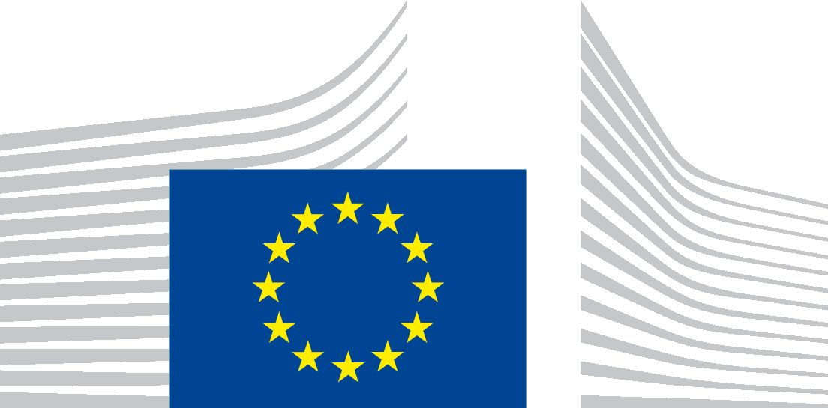

The Environment Protection Agency intends to award a service contract for the Comprehensive support to the implementation of sustainable urban mobility deliverables, including pilot solutions, awareness measures, and strategic engagement under the ADRIAMOVE project framework- Budva, Montenegro
with financial assistance from the programme of the European Union. The tender dossier is available from office4eu@budva.me.
The deadline for submission of tenders is June 16th, 2025. at 12:00h.
All additional information or clarifications/questions shall be published on the
www.budva.me.

